Diario #1 - Family Tree Sentences
In Spanish and English, write 10 sentences saying how one of these people is related to another of these people.
Example: Darth Vader is the father of Luke Skywalker.
Darth Vader es el padre de Luke Skywalker.
You must use the word OF ( “de”) in each sentence.
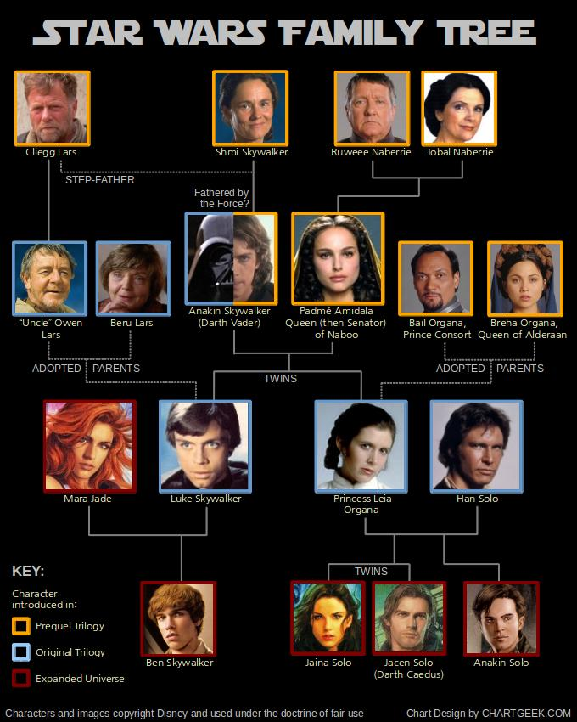

Diario #2 – Possessive Adjective Practice
Directions: Using your Unit 2 Vocab List and the Possessive Adjective Notes, translate the following phrases into Spanish.
- My aunt
- His father
- Our grandmothers
- Your (singular/formal) cousin (female)
- Your (singular/familiar) brother
- Her grandparents
- Your (plural/Spain/informal) uncles
- Your (plural/Latin America) brothers and sisters
- Our parents
- Their cousins (mixed gender)

Directions: Using your Unit 2 Vocab List and the Possessive Adjective Notes, translate the following phrases into English
- Tu tío
- Sus padres
- Nuestras abuelas
- Sus nietos
- Mis sobrinas
- Su prima
- Vuestro hermano
- Mis hermanastros
- Tu madrina
- Nuestros hijos

Diario #3 – POSSESSIVE ADJECTIVES: Practice Test

- Choose the correct translation.
  - your (informal) classes
  - his son
  - our daughter
  - my book
- Write the correct word in order to form a logical response.
  - ¿Dónde trabaja su esposo?
Where does your husband work? esposo trabaja en el aeropuerto.
  - ¿Dónde está su tienda?
Where is her store? tienda está en el centro.
  - ¿Cuándo abren los niños sus regalos?
When do the kids open their gifts?Ellos abren regalos mañana.
  - ¿Necesitan ustedes nuestros libros?
Do you-all need our books?Sí, necesitamos libros. (formal)
- Write the answer that forms a correct translation.
  - her book
el libro de
  - Marta's pen
la pluma de
Diario #3 - POSSESSIVE ADJECTIVES: Practice Test Answers

- Choose the correct translation.
  - your (informal) classes
  - his son
  - our daughter
  - my book
- Write the correct word in order to form a logical response.
  - ¿Dónde trabaja su esposo?
Where does your husband work? esposo trabaja en el aeropuerto.
  - ¿Dónde está su tienda?
Where is her store? tienda está en el centro.
  - ¿Cuándo abren los niños sus regalos?
When do the kids open their gifts?Ellos abren regalos mañana.
  - ¿Necesitan ustedes nuestros libros?
Do you-all need our books?Sí, necesitamos libros. (formal)
- Write the answer that forms a correct translation.
  - her book
el libro de
  - Marta's pen
la pluma de
Diario #4 – Family Tree Project Part 1
FAMILY TREE PROJECT

- You are going to create a diagram of your family OR a pretend family from a television show or movie.
- You must include a minimum of 10 family members
- Please consult your Unit 2 Vocabulary List

Writing: Each person on the family tree needs to be labeled with:
- Éste/Ésta es (their name),
- Él/Ella es el/la (their family word-like madre) de (your name.)
- Label yourself with your name!

Example: Éste es Jerome. Él es el hermano de Señor Gleason. (This is Jerome. He is the brother of Mr. Gleason)
Effort: This should be neat. It should look like you worked hard on it. It should look like it took time.
Frequently asked questions:
- If you have many siblings, list at least 2.
- If you have several sets of parents, list at least 2.
  - Legal guardian in Spanish is “tutor legal”
- You make the final decisions on including family members or leave them off.
If you prefer, use a pretend TV or movie family that most people would know. Just let me know it is a TV family on the back. You have to put yourself in that family and make the sentences make sense.

Diario #5 – Family Tree Project Part 2
You will reference your family tree from yesterday’s work.

Now you will write one additional sentence, in English and Spanish, for each person on your family tree.
You will use the appropriate possessive adjective, vocabulary word, form of ‘SER’ and descriptive adjective.
***Make sure your adjectives agree in gender/number with the nouns they modify

Example:
If you included your mother in your family tree, your sentence could read:
- My mother is nice.
- Mi madre es simpática.

