Chapter 1 Summative Review Name ______________
- What is an independent quantity? What is a dependent quantity?

- For each scenario listed below, identify the independent and dependent quantities.

  - Hector knows there is a relationship between the number of cars he washes and the amount of money he makes for washing them.

  - David rode his bike to the park, stopped for a few minutes, and then continued on his way to the store.

  - Angela knows there is a relationship between her grades in school and the number of school days she is absent each marking period.

- How can you determine if a graph represents a function or not?

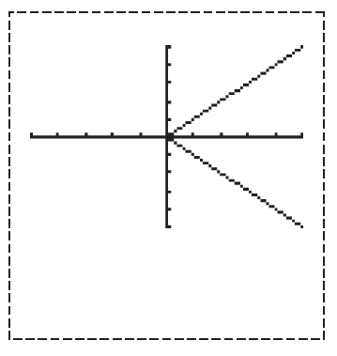
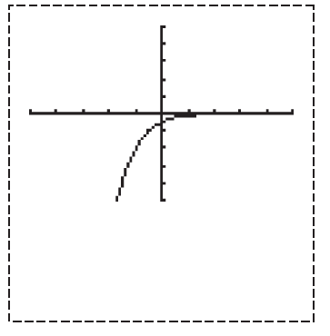
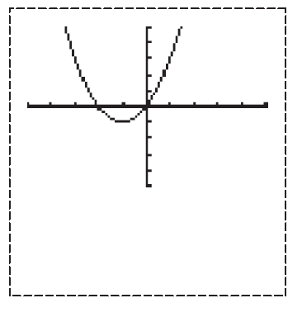
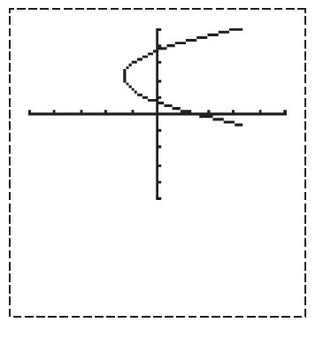
- Tell whether each graph represents a function or not.
a. b. c. d.

- Circle the correct characteristics for each function family.
Quadratic
Increasing and/or Decreasing
Straight Line Curved Line
Absolute Maximum Absolute Minimum
Has symmetry Does Not have symmetry
Linear
Increasing and/or Decreasing
Straight Line Curved Line
Absolute Maximum Absolute Minimum
Has symmetry Does Not have symmetry

Exponential
Increasing and/or Decreasing
Straight Line Curved Line
Absolute Maximum Absolute Minimum
Has symmetry Does Not have symmetry
Linear Absolute Value
Increasing and/or Decreasing
Straight Line Curved Line
Absolute Maximum Absolute Minimum
Has symmetry Does Not have symmetry

- Create an equation and sketch a graph for each set of given characteristics.
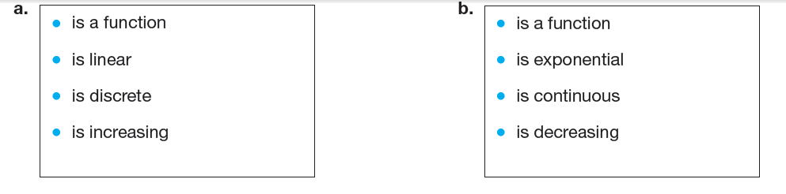

Equation ________________________ Equation ________________________

